Proposal Round Robin exercise: collating wind tunnel data for the basic shapes of tensioned surface structures
Marijke Mollaert, Alex Michalski, Steve Vanlanduit, Jimmy Colliers, Maarten Van Craenenbroeck, Lars De Laet, Jean-Christophe Thomas, Peter Gosling

Introduction
A Round Robin exercise is launched to collate existing wind tunnel test results for simple fabric structures. It is the general purpose of the Round Robin exercise to explore the available existing (but fragmented) experimental pressure coefficient distributions for different basic doubly curved forms and to create a reference for further systematic and complementary test campaigns.

The analysis of membrane structures can only benefit from improved and more precise wind load estimations. Currently wind loading on tensioned surface structures is often based on rough approximations referring to flat or spherical shapes. Appropriate wind pressure data is essential to provide confidence in the analysis and design process, and to ensure the development of the Eurocode that will facilitate the safe and efficient design of membrane structures.

The Round Robin exercise is proposed as a non-commercial activity. It is intended to serve the purpose of advancing the scientific and engineering practice in the analysis and design of membrane structures.
Participation in the Round Robin exercise is voluntary and undertaken without fee. Contributors to the exercise will be acknowledged in all disseminations (journal papers, reports etc.), but individual results will be anonymous, i.e. a particular set of results will not be attributed to a particular participant. Ownership of the data will remain with the participants.

Alex Michalski proposes that a first series of wind tunnel tests should consider the basic shapes with variable shape parameters H (height), B (width), b (diameter of the top), L (length), f (height of the arch), s (sag at the boundaries) and t (thickness) (see Figure 1). Additional parameters could be the position or the inclination of the poles.
A second series of tests could verify the addition of walls or facades. Membrane roofs should be tested in open and (partly) closed situations.
A third series of tests could be performed on a sequence of elements or modules. A series arrangement will drastically affect the wind loading (cfr. multibay roof).
Within the perspective to use the results in the Eurocode, standardized tests (angels of attack, wind speed…) are required, with a specific wind profile (cat. III: Suburban).

Before starting new experimental verifications it is the aim to collate existing data. Research institutes, universities, specialized laboratories and engineering offices are asked to present the available experimental data for basic forms in a uniform way to allow comparing and interpolating the information. Further, where crucial data is missing new experimental campaigns should be launched. Therefore engineers and research institutes experienced in performing wind tunnel tests are invited to perform standardized wind tunnel test on the basic membrane forms. The standardized results could be used for a prospective Eurocode section on wind loading for tensile surface and shell structures.
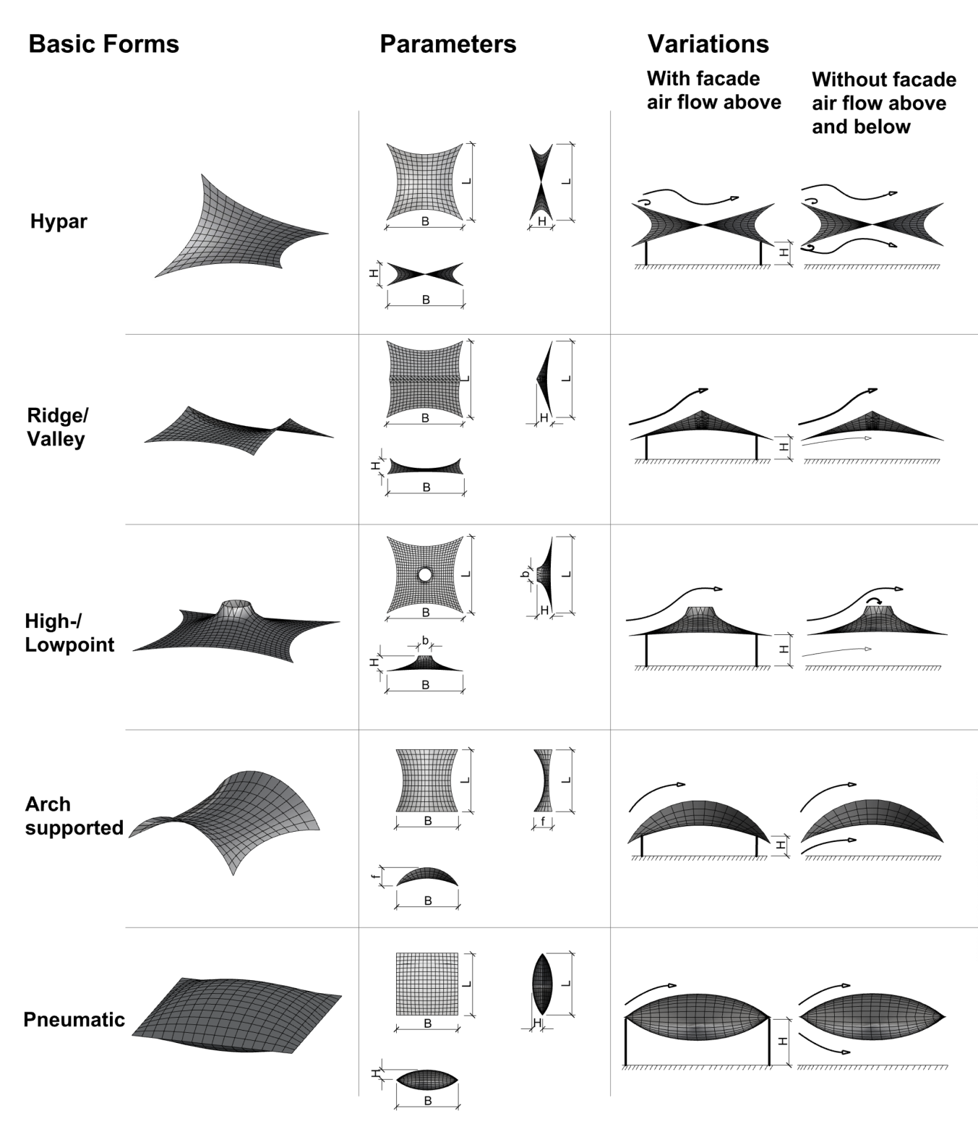
Figure 1. Overview of basic shapes, established by Alex Michalski

When collating the wind tunnel test data on basic shapes a general description of the performed tests should be made available in a uniform way. A standardised results sheet has to be specified to be able to present, compare and interpolate the results:

- description of the wind-tunnel
  - boundary layer profile (cfr. scale model)
  - measuring device
- description of the model + photos
  - plan and elevations
  - material and finishing
  - locations and dimension of the measuring points
  - shape parameters H, B, b, L, f, s (sag at the boundaries) and t (thickness)
- results for a given wind speed and for different angles
  - open canopy: wind direction, c_{pe}, c_{pi} in top view (+ table?)
  - partly open configuration: wind direction, c_{pe}, c_{pi} in top view (+ table?)
  - closed building configuration: wind direction, c_{pe} in top view (+ table?)
  - post processing (sampling length and frequency, mean and peak loads)
  - …

Presentation of a 1st set of experimental data

Large Wind Tunnel VUB
Type: Open Return Wind Tunnel
Manufacturer: T.E.M. ENGINEERING LIMITED Crawley England
Working cross section: 2 m x 1 m
Maximum wind speed: 20 m/s
Maximum blockage: 5-10%

The wind tunnel tests, performed by Jimmy Colliers at the Vrije Universiteit Brussel, fit in the overview given in Figure 1 (first line):
L=B=400mm; shape parameter (diagonal/height) = 11.3; sag at the boundaries = 0%;
Height difference H=50mm; Height above ground: 115mm (low corner point, centerline) and 165mm (high corner point, centerline)
Thickness: ~5mm
An open canopy was tested as well as a ‘closed building’ configuration.

Hypar canopy structure with a shape parameter of 11.3

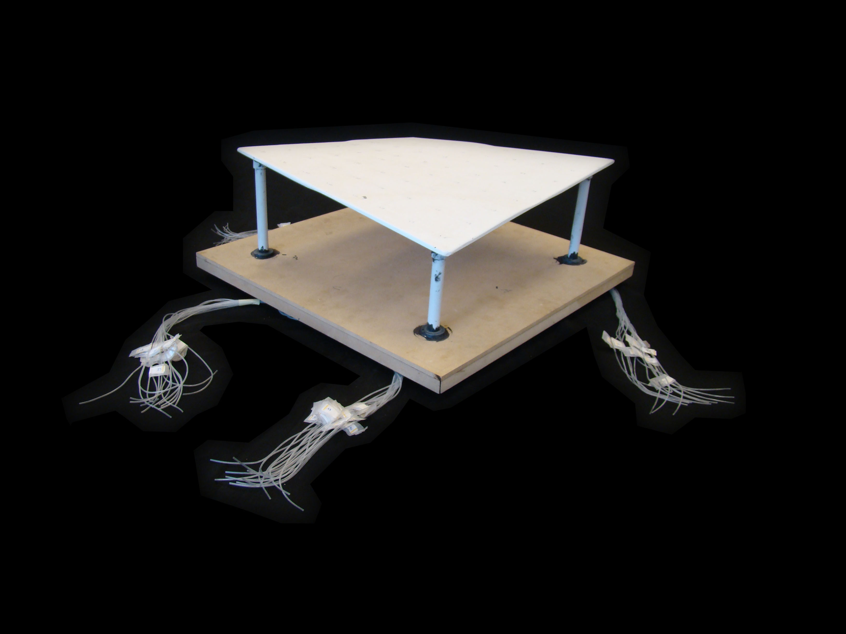  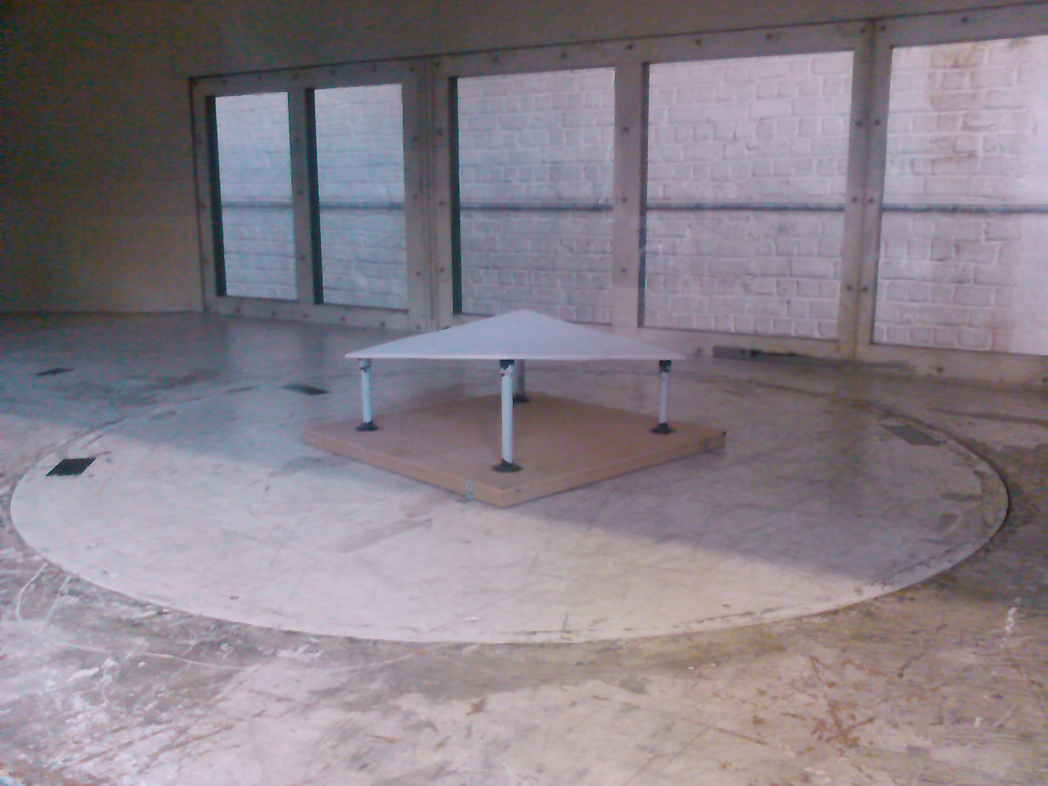 | Model | Hypar roof
 | Walls | No
 | Number of pressure taps | 62 (32 upper + 30 lower face)
 | Maximal tunnel blockage for this model | 1,36%
 | Wind direction | 0° - 180°, steps of 15°
 | Flow type | Free Field
 | Wind velocity | 15 m/s
 | Atmospheric pressure | 100110,3 ± 5,63 Pa
 | Relative humidity | 62 ± 0,1%
 | Temperature | 23,1 ± 0,04 °C
 | Air density | 1,18476 kg/m³
 | Number of samples | 500
 | Sampling frequency | 10 Hz
 | Sampling length | 50 s
Table 1: Wind tunnel testing conditions

The net pressure coefficient distributions for the hypar canopy roof are generated for wind orientations of 0° up to 180°, with increments of 15°. The sequence of experimentally obtained net pressure coefficient distributions for wind orientations ranging between 45° (the high corner under attack) and 135° (low corner under attack) (using the diagonal bisymmetry of the hypar canopy roof ) is presented in Figure 2

45° | 75° | 90° | 105° | 135°
Figure 2: Wind tunnel net pressure coefficient distributions – discrete angles – hypar canopy with a shape parameter of 11.3

Hypar roof part of building envelope with a shape parameter of 11.3

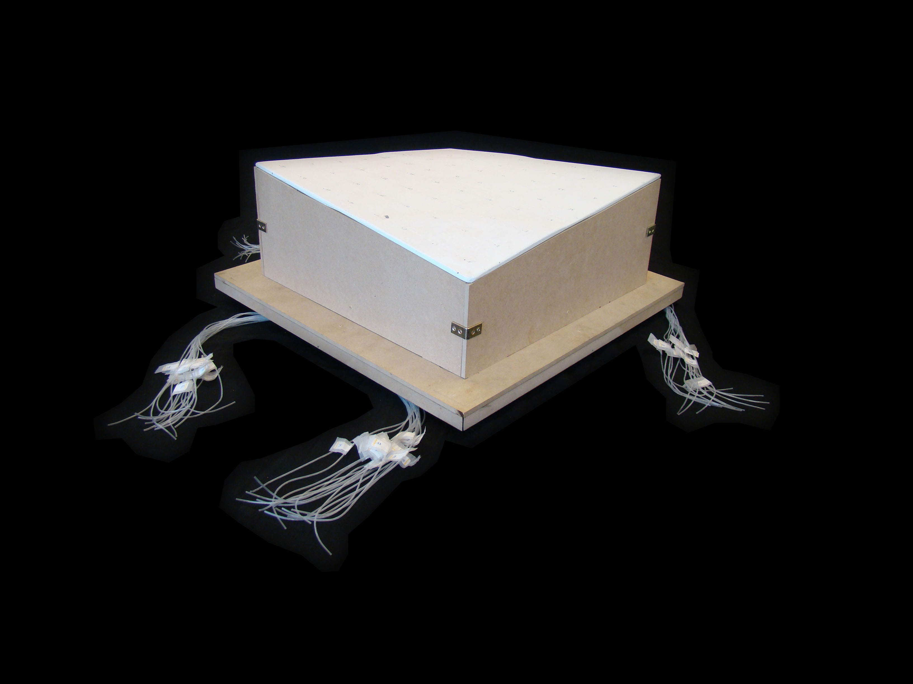  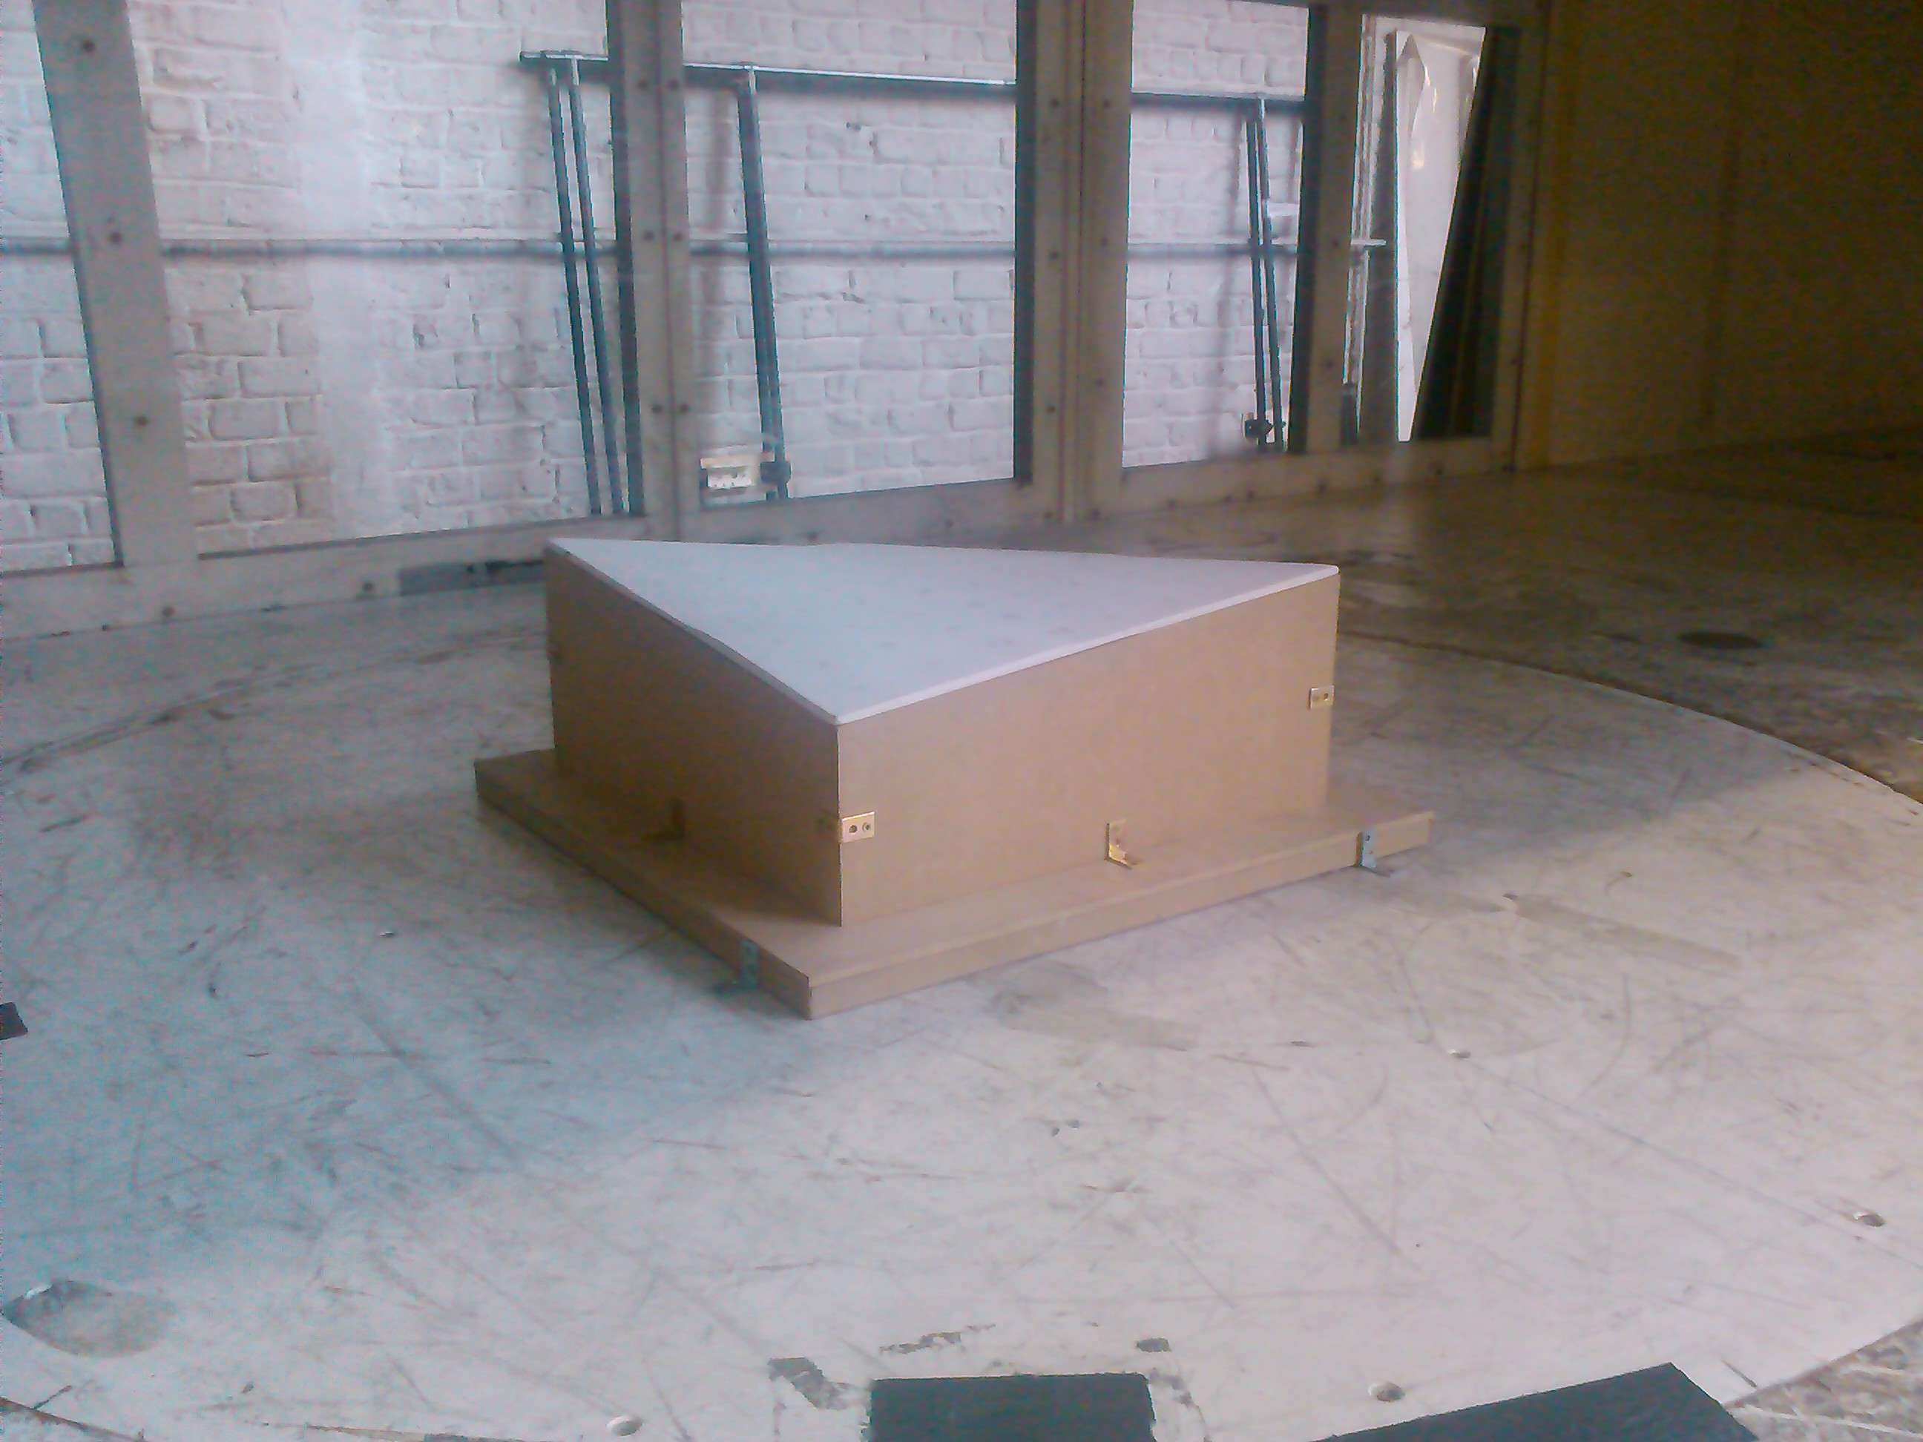 | Model | Hypar roof
 | Walls | Yes
 | Number of pressure taps | 62 (32 upper + 30 lower face)
 | Maximal tunnel blockage for this model | 3,75%
 | Wind direction | 0° - 180°, steps of 15°
 | Flow type | Free Field
 | Wind velocity | 15 m/s
 | Atmospheric pressure | 100146,3 ± 5,66 Pa
 | Relative humidity | 63 ± 0,1%
 | Temperature | 21,9 ± 0,04 °C
 | Air density | 1,18992 kg/m³
 | Number of samples | 500
 | Sampling frequency | 10 Hz
 | Sampling length | 50 s
Table 2: Wind tunnel testing conditions

The sequence of experimentally obtained external pressure coefficient distributions for wind orientations ranging between 45° and 135° is presented in Figure 3. The range from 0° up to 45° and from 135° up to 180° is excluded from the sequence as a consequence of the diagonal bisymmetry of the hypar roof. The aerodynamics and thus the orientation of the hypar building roof relative to the wind angle of attack has a significant influence on the pressure distributions. Most extreme pressure coefficients are observed locally at different zones for different orientations. A clear relationship between the increment in orientation and the shift of these extreme coefficients is observed. Highest suction coefficients are observed locally close to the upwind corner and edge areas, with most extreme values for the high corner under attack (rotation of 45°) and slightly lower values for the low corner under attack (rotation of 135°). In addition it is clear to see that suction generally reduces towards the central and downwind areas of the hypar roof, except with the low corner under attack where suction remains more or less constant over the central and downwind areas.

45° | 75° | 90° | 105° | 135°
Figure 3: Wind tunnel external pressure coefficient distributions – discrete angles – hypar roof with a shape parameter of 11.3

Contact details | Contributors
ir.-arch. Jimmy Colliers  Jimmy.Colliers@vub.ac.be  Prof. dr. ir. Marijke Mollaert  Marijke.Mollaert@vub.ac.be  architectural engineering lab (ae-lab)  Vrije Universiteit Brussel  Cost Action: http://www.cost.eu/domains_actions/tud/Actions/TU1303  http://www.novelstructuralskins.eu | Pierre Spehl  Ben Bridgens

